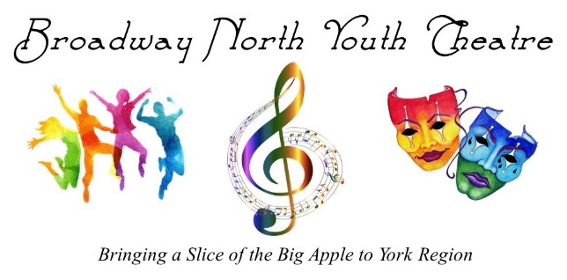

TEEN TROUPE’S INTRODUCTION PACKAGE

Welcome to Broadway North Youth Theatre! We are very excited to begin a new session with both new and returning students and we are looking forward to another fantastic year and more stellar final performances in this session’s play: GREASE! Please read the following pages as it includes some valuable information regarding our program. We kindly request that you sign and return the final page of this document as an acknowledgement that you have read and understood the information contained herein.

GENERAL CLASS INFORMATION

*Broadway North is a peanut-free facility so please ensure that any snack you pack is peanut-free. It is always advisable to pack a bottle of water.
*We ask that electronic devices be left at home if at all possible as you will not be allowed to access them during class time. If you do bring a phone, it must be kept off during rehearsals.
*You will be supplied with 1 script. If you lose it and need a replacement, a copy will be emailed to you for you to print out at home or we can print a new one at a cost of $10. Sheet music will be supplied to you as/if needed.
*We will be sending out periodic emails with course updates. Please make sure to check your email consistently.

REHEARSALS, ATTENDANCE, ABSENCES & LATENESS

*In order to make sure we teach all required materials in plenty of time, we take great care to create a schedule and do our best to stick to it.
*If you know you are going to be absent from class due to an appointment, holiday, etc. PLEASE let us know as soon as you can. We create our schedule based on the assumption that all participants will be in class at all times and although we certainly understand that this is not always possible, the sooner we know of any absences, the sooner we can make changes to the schedule and make the best use of time with those participants we know will be in class.

* CONSISTENT ATTENDANCE AT REHEARSALS IS EXPECTED. IF YOU ARE FREQUENTLY ABSENT, YOUR ASSIGNED MATERIAL MAY BE AFFECTED.
*If you are ill and cannot come to class, please send an email to info@broadwaynyt.com as our emails ARE forwarded to our phones. Please ensure that you arrive on time. If you will be late, just send us a quick email to the info address listed above.

PRACTICE

As with any performance-based program, practice is of absolute paramount importance for a successful final show. Once we have taught a dance, vocal number or acting scene, we ask that you go home and LEARN it as best as possible from memory. The kids’ stuff page of our website will have crucial learning tools to help you succeed!
**KIDS’ STUFF PAGE: TEEN REHEARSAL NOTES
- All vocal and non-vocal music tracks for GREASE will be posted on this page. If you find that you cannot access them, please change browsers and this should solve any problems. These tracks are fully downloadable. Any changes to keys, any recorded harmonies etc. will be uploaded to this page.
- All choreography videos will now be posted on this site and a link will be posted on this page.
**KIDS’ STUFF PAGE: TEEN TROUPE SCHEDULE
- This page will list all songs, scenes and dances that we will be working on in upcoming classes. Please refer to this consistently so you are well prepared for each class. Although we try to stick to this schedule as much as possible, it is possible that changes will need to be made due to unforeseen circumstances.

AS A REMINDER, THE PASSWORD TO ALL THESE PAGES IS: Rydell

It is crucial to the overall success of the show that practice be done AT HOME. By learning things bit by bit rather than “cramming” at the end, there is far less pressure on you closer to the end of the session and more time to work on the nuances of character. The better and sooner you know the material, the more comfortable you will feel on stage. Please ensure that assigned material is being practiced consistently. If you have any questions, do not hesitate to email or call.
*If you wish to reach out to any of our instructors for clarification on anything taught in class or to arrange for extra help or private lessons outside of scheduled class time at an additional cost, please contact them directly at the following email addresses. We are always available to answer your questions or concerns.
Acting/Staging: Laura Halley: laura@broadwaynyt.com
Singing/Music: Shoshana Friedman: shoshana@broadwaynyt.com
Dancing/Choreography: Darren Fletcher: fletcherdarren@rocketmail.com

OBSERVED HOLIDAYS

Broadway North does not hold classes on traditional Statutory Holidays.
We DO, however, hold classes on days when Public or Private schools may have PA days.

SHOW DATES/TIMES/TICKETS

*Tickets for all our Teen Troupe shows are available online through The Town of Newmarket’s website and a link will also be available on the TICKETS page of Broadway North’s website. As soon as tickets go on sale through the theatre’s box office, we will send out an email letting you know. We will send out a finalized schedule for dress rehearsal and showtimes ( THE TWO PERFORMANCES OF GREASE WILL BE HELD ON SATURDAY, FEB.24/24 ) within the next few months. Please ensure that you keep your schedule free for the final few weeks before showtime as we will be doing full runs and attendance is extremely important.

*** ATTENDANCE AT DRESS REHEARSAL AND ALL SHOWS IS MANDATORY.

DRESS REHEARSAL AND ALL SHOWS TAKE PLACE AT
NEW ROADS PERFORMING ARTS CENTRE
505 PICKERING CRESCENT, NEWMARKET

PLEASE RETURN THIS PAGE TO BROADWAY NORTH IN PERSON OR SEND AN EMAIL CONFIRMING THAT YOU HAVE READ ITS CONTENTS:

I HAVE READ THE ABOVE LETTER AND ACKNOWLEDGE ITS CONTENTS.

PARTICIPANT’S SIGNATURE ____________________________________________________

PARENT’S SIGNATURE: ______________________________________________________

